

**NODERED+POSTGRESQL WORKFLOW IMPLEMENTATION FOR DIMO DIESEL CONSUMPTION ANALYSIS**

**MALAVIKA K.V**

**NODE-RED INSTALLATION SETUP**

1. Node-red installed in a docker inside a server iplon-pvindia.com in the port 1880 by using the command inside iplon-pvindia.com server

docker run -itd --name nodered_dimo_test --network host nodered/node-red

once the node-red docker installation finished we can access node-red in the url <http://iplon-pvindia.com:1880/>

A node-red workspace will open on the left side of workspace there will nodes to work on and in right side debug window to show outputs.

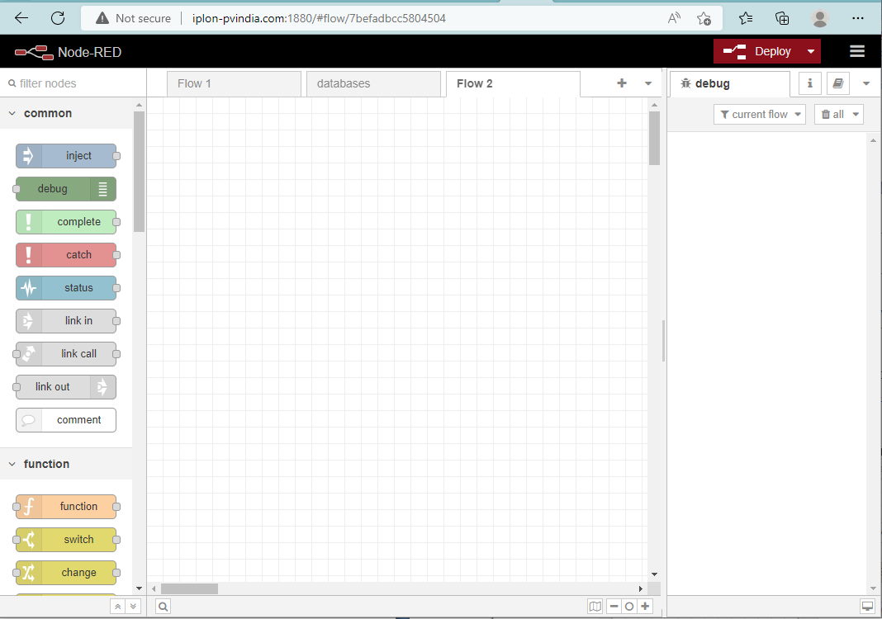

**DIMO DIESEL CONSUMPTION ANALYSIS PROJECT REQUIREMETS**

* Node-red flowfor creating table inside the postgres which running in iplon- pvindia.com server and one more flow for get data from influxdb dimo database for last 24h and take start time, end time , duration and number of power cuts,DG1,DG2, SOLAR, Total load at that particular time period.
* Tags Needed in the DG Analysis Postgres Table

Date in hr:mm:ss  
2. Grid Down count in No  
3. Grid Down Start Time in Hr:mm:ss  
4. Grid Down End Time in Hr:mm:ss  
5. Grid Down Duration in Hrs  
6. DG1 Generation in kWhr  
7. DG2 to DGn Generation in kWhr  
8. Solar PV generation in kWhr  
9. Total Demand in kWhr (Sum of DG + Solar)

* Visualization of postgres table in Grafana

**NODE-RED FLOW:**

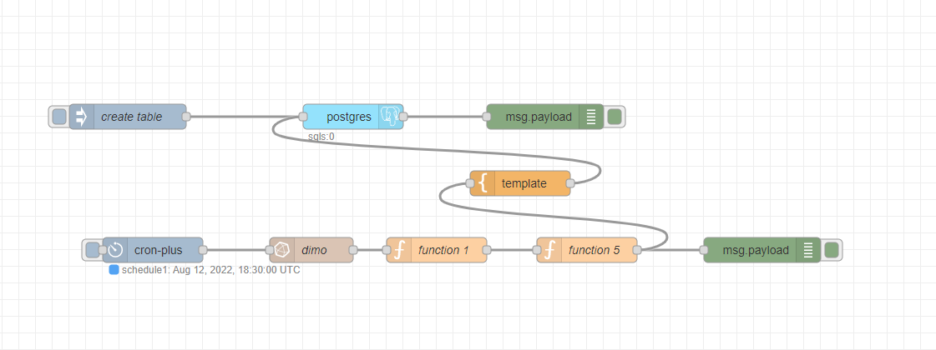

**Inject Node:**

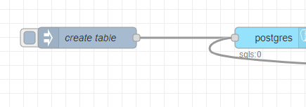

1. The Inject node allows you to inject messages into a flow, either by clicking the button on the node, or setting a time interval between injects.
2. Drag one onto the [workspace](https://nodered.org/docs/user-guide/editor/workspace/) from the [palette](https://nodered.org/docs/user-guide/editor/palette/).
3. Set msg.payload as SQL query to create table inside postgres databse

SQL Query: CREATE TABLE public.DIMO( "DATE" numeric PRIMARY KEY, "POWER_CUT" numeric,"START_TIME" text,"END_TIME" text,"Duration (hr)" numeric,"Gen1(kwh)" numeric,"Gen2(kwh)" numeric,"Total_solar(kwh)" numeric,"Total_Load(kwh)" numeric) WITH ( OIDS=FALSE )

When the inject node trigged it will create a table inside datase

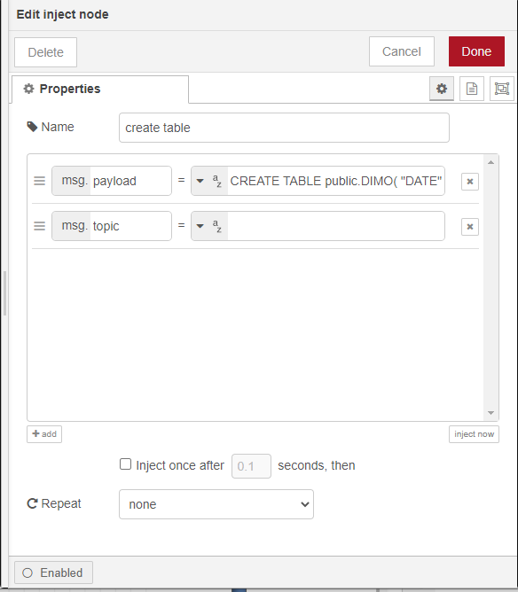

**Postgres Node** ([node-red-contrib-re-postgres (node) - Node-RED (nodered.org)](https://flows.nodered.org/node/node-red-contrib-re-postgres)**):**

To access this node we have to install the node package(node-red-contrib-re-postgres)from manage pallette feature(click 3 lines symbol in the top right corner in the node-red workspace)

Node to access postgres database from node-red

double click on the postgres node

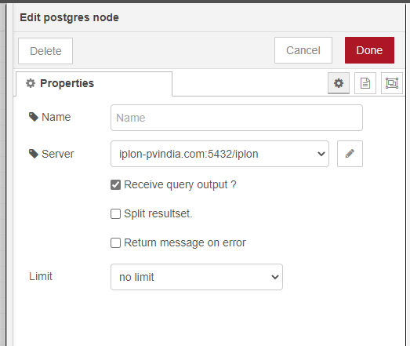

Click on the pencil icon to give server configration

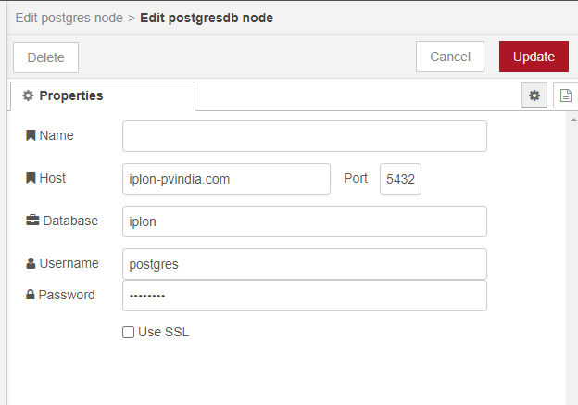

Feed host,port,database,username,password in the corresponding boxes to connect the postgres server from node-red

**Cron Plus node:(**[node-red-contrib-cron-plus (node) - Node-RED (nodered.org)](https://flows.nodered.org/node/node-red-contrib-cron-plus))

To access this node we have to install the node package(node-red-contrib-cron-plus)from manage pallette feature(click 3 lines symbol in the top right corner in the node-red workspace)

Set cron as 0 30 18 * * * so this will trigger the flow everyday 18.30 (UTC Time)ie, 12AM(IST)

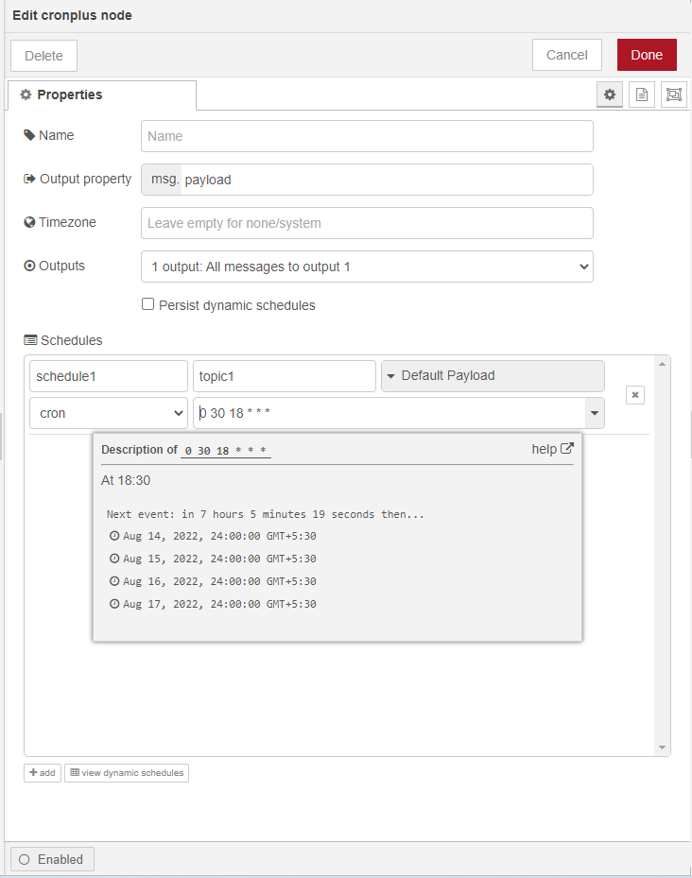

**Influxdb in node** ([node-red-contrib-influxdb (node) - Node-RED (nodered.org)](https://flows.nodered.org/node/node-red-contrib-influxdb)**):**

To access this node we have to install the node package(node-red-contrib-influxdb)from manage pallette feature(click 3 lines symbol in the top right corner in the node-red workspace)

Nodes to query data from an influxdb time series database. Supports InfluxDb versions 1.x to 2.0.

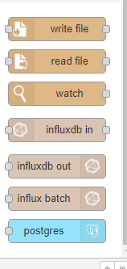

Drag&Drop this node to workspace double click on the influx db node

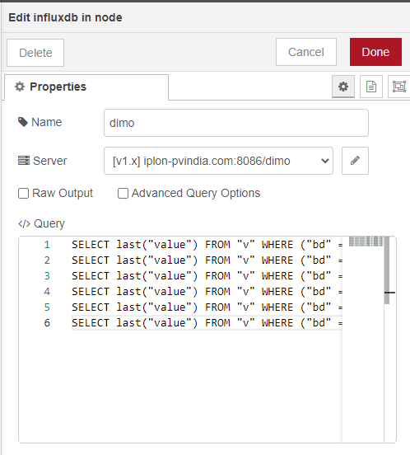

Write the influx query in the query box given

SELECT last("value") FROM "v" WHERE ("bd" = 'dimo_700W' AND "d" = 'GRID_EM' AND "f" = 'UAC12') AND time >= now() - 1d GROUP BY time(1m), "d", "f" fill(none);

SELECT last("value") FROM "v" WHERE ("bd" = 'dimo_700W' AND "d" = 'GRID_EM' AND "f" = 'UAC23') AND time >= now() - 1d GROUP BY time(1m), "d", "f" fill(none);

SELECT last("value") FROM "v" WHERE ("bd" = 'dimo_700W' AND "d" = 'GRID_EM' AND "f" = 'UAC31') AND time >= now() - 1d GROUP BY time(1m), "d", "f" fill(none);

SELECT last("value") FROM "v" WHERE ("bd" = 'dimo_700W' AND "d" = 'DG2' AND "f" = 'EAE') AND time >= now() - 1d GROUP BY time(1m), "d", "f" fill(none);

SELECT last("value") FROM "v" WHERE ("bd" = 'dimo_700W' AND "d" = 'DG1' AND "f" = 'EAE') AND time >= now() - 1d GROUP BY time(1m), "d", "f" fill(none);

SELECT last("value") FROM "v" WHERE ("bd" = 'dimo_700W' AND "d" = 'SOLAR_EM' AND "f" = 'EAE') AND time >= now() - 1d GROUP BY time(1m), "d", "f" fill(none)

Then click on the pencil icon to add details of the new server

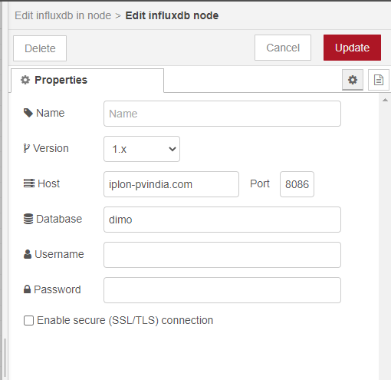

Version =1.x

Host = iplon-pvindia.com

Port = 8086

Database = dimo(use the same database name used in influx db)

**Influx db output:**

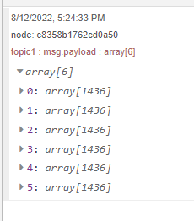

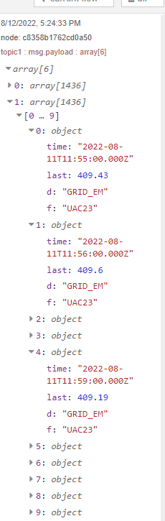

**Function node:**

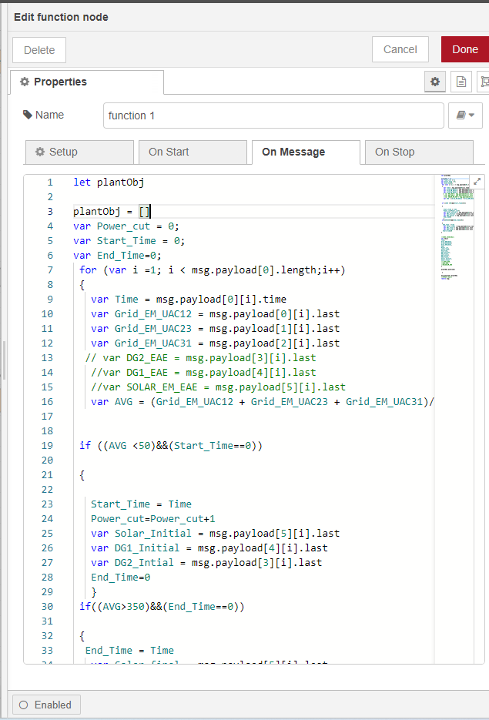

In this function node i am taking input from influx db defining array and creating for loop for iterate each array values from input defining msg paths and calculating average of grid diving the sum of grid values by 3

After that setting if condition to get start and end timing of DG’s operation if avg<50 it will start count the start timing intial DG values

if avg>350 it will start count end timing and final DG value

Function output:

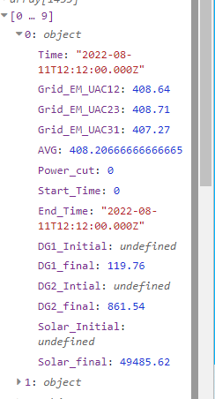

**Function Node:**

First function output i am giving to another function to filter out start time and end times and calculate duration time DG Loads,solar loads, total loads during the powercut period.

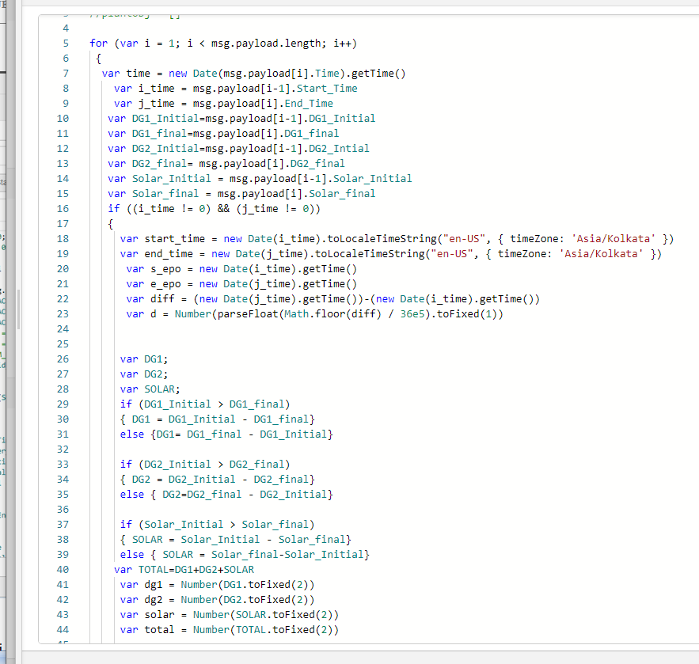

**Template Node:**

Node connected between last function node and postgres node

Template node used to insert the values to postgres table here using the mustache syntax here we have to mention the table name and column names and insert the value message path in the corresponding order of column name given in INSERT INTO query

**INSERT VALUES QUERY**

Mention column name same as how you gave at the time table creation

Give the value message path in the corresponding order of column name

INSERT INTO public.DIMO("DATE","POWER_CUT","START_TIME", "END_TIME",, "Duration (hr)", "Gen1(kwh)", "Gen2(kwh)", "Total_solar(kwh)", "Total_Load(kwh)")

VALUES ( '{{payload.time}}', '{{payload.p}}', '{{payload.start_time}}', '{{payload.end_time}}', '{{payload.d}}', '{{payload.dg1}}', '{{payload.dg2}}', '{{payload.solar}}', '{{payload.total}}')

**Debug node:**

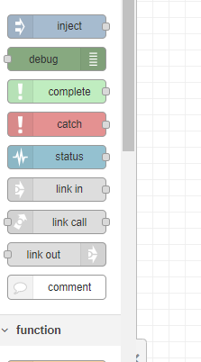

The Debug node causes any message to be displayed in the [Debug sidebar](https://nodered.org/docs/user-guide/editor/sidebar/debug). By default, it just displays the payload of the message, but it is possible to display the entire message object.

1. Click the Deploy button.With the Debug sidebar tab selected,
2. Click the Inject button to get output if there is no triggerng time set.
3. Check the destination of file what we give as path to check whether the csv file created or not

